

**Lancaster General Health**

**Contractor Safety Management Orientation Manual**



**Instructions for using the Lancaster General Health Contractor Orientation Manual:**

1. Prior to beginning any work, provide this orientation manual to all contractors who will be performing work in a Lancaster General Health facility. Make copies of the content of the orientation manual as needed.
2. Once the orientation manual/power point has been reviewed, sign a copy of the **Lancaster General Health Contractor Safety and Guideline Review**
3. Return a copy of the signed **Lancaster General Health Contractor Safety and Guideline Review** to the LGH Safety Department by any of the following means:
   1. Email:

Denise.Parke@pennmedicine.upenn.edu

Angela.Mackley@pennmedicine.upenn.edu

* 1. USPS

Safety Department

524 North Duke Street

Lancaster, PA 17604

1. Return all completed inspection forms to the LGH Safety Department by any of the following means. This includes the Daily Inspection Sheet and the Hourly Fire Watch form.
   1. Email:

Denise.Parke@pennmedicine.upenn.edu

Angela.Mackley@pennmedicine.upenn.edu

* 1. USPS

Safety Department

524 North Duke Street

Lancaster, PA 17604

1. Contact the LGH Safety Department to discuss the contents and become familiar with the use of the orientation manual. This is encouraged particularly if this is the first time the manual has been used.
   1. Denise Parke 717.544.4844
   2. Angela Mackley 717.544.4772

**CONSTRUCTION SAFETY MANAGEMENT ORIENTATION LETTER**

Dear Contractor,

Welcome to Lancaster General Health. As a contract employee, you will be working in an organization with a rich history of providing health care services to the communities of Lancaster County. Lancaster General Health’s mission is “to advance the health and well-being of the communities we serve”. To that end our vision is “to create an extraordinary experience…every time”. As a contractor, you serve a vital role in Lancaster General Health’s ability to create that level of experience.

Lancaster General is a Star Site, recognized through the Occupational Safety and Health Administration’s (OSHA) Voluntary Protection Program (VPP). As a VPP site we want you to be safe while working, so it is important that you are familiar with safety procedures and also practice safe behaviors.

For contractors, one of the biggest challenges is working in close proximity to patient care areas while not disrupting patient care. In all cases, patient care activities have the highest priority. Every aspect of your work at our facilities, including your conduct on the job, has the potential to affect our operations, so it is vital that we work together to do all we can to minimize disruption to our patient care services.

Lancaster General Health promotes a safe and healthy work environment.  Unsafe conditions and unsafe acts can result in property damage or injuries to patients, visitors, employees, volunteers, or contract personnel. Medical facilities operate under strict rules and regulations enforced by several regulatory agencies including the Joint Commission and OSHA. Compliance with the regulations set forth by these governing bodies provides guidance on the minimum requirements of safety. In the hospitals, as well as in the outpatient settings, there are additional concerns for security, infection control, and life safety, which require extra awareness and caution.

The precautions that must be observed while working in Lancaster General Health facilities apply to all contractors and subcontractors who are performing work.  General safety orientation is provided in this orientation manual. Annually, contractors are required to review the “Contractor Safety Management Orientation Manual”. This is to ensure that everyone remembers the Lancaster General Health safety standards and are alerted to any changes or new information.

Periodic inspections of your worksite will be conducted by the Lancaster General Infection Control, Safety, and Project Management departments to ensure your safety by monitoring work practices, as well as the work environment.

Good luck with your assignment. Thanks for working safely and for making sure those around you are also working safely. Your contribution to Lancaster General Health’s safe working environment, as well as to the important services we provide our communities is appreciated.

Sincerely,

Angela Mackey Denise Parke

Director of Safety and Emergency Management Safety Specialist

**Contractor Safety Management Orientation Manual**

**Index**

Page

1. Project Site Safety and Life Safety
   1. Orientation to Construction Safety and Life Safety Management 5
   2. Guideline for Construction Safety Management 9
   3. Safety Specifications and Life Safety Requirements 15
   4. Emergency Information and Contact Information 17
2. Lancaster General Hospital & OSHA Voluntary Protection Program
   1. All About VPP 18
   2. Lancaster General Request for Injury and Illness Rate Information 19

Created: May 2010

Revised: February 2019

|  |  |  |  |
| --- | --- | --- | --- |
| Orientation to Construction Safety and Life Safety Management |  | | |
|  |  | | |
|  |  | | |
|  | |  |
|  | |  |
|  | |  |

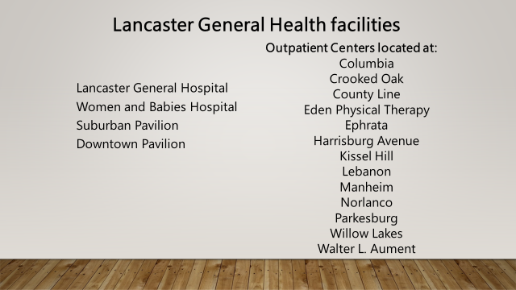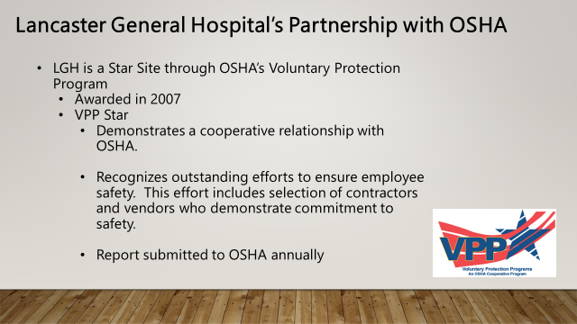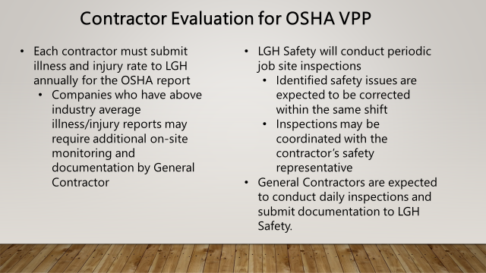

|  |  |
| --- | --- |
|  |  |
|  |  |
|  |  |

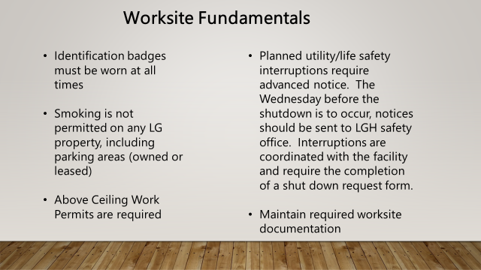

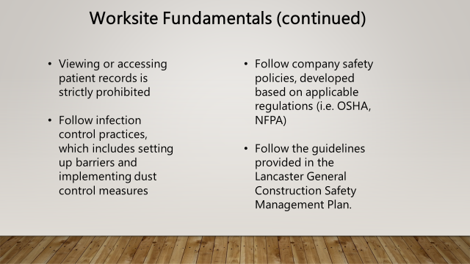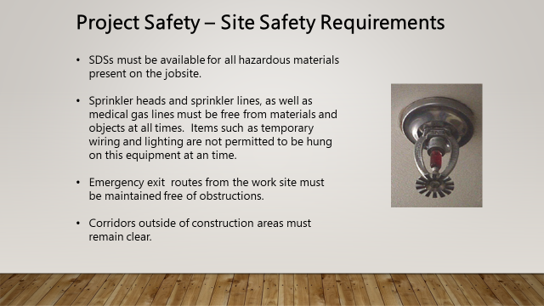

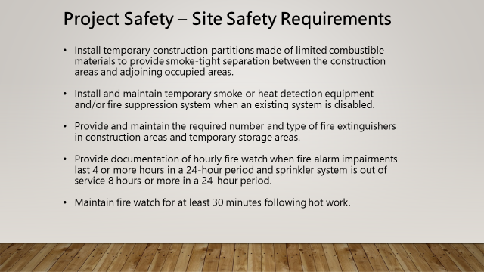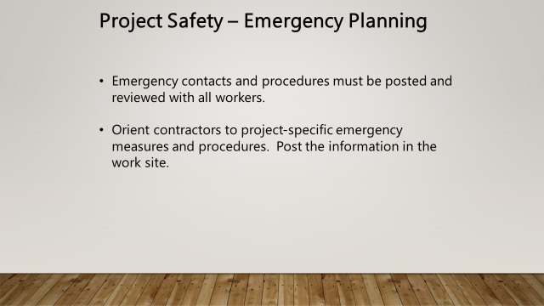

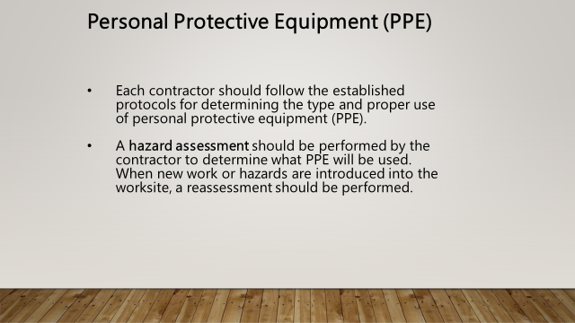 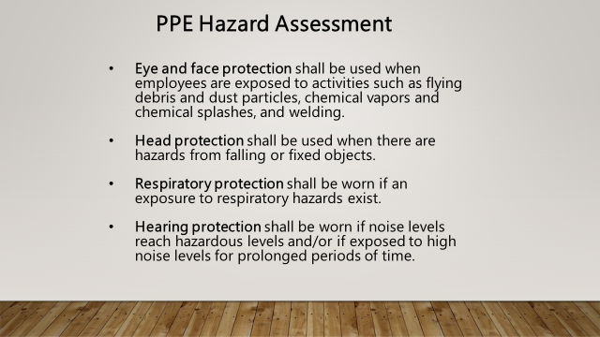

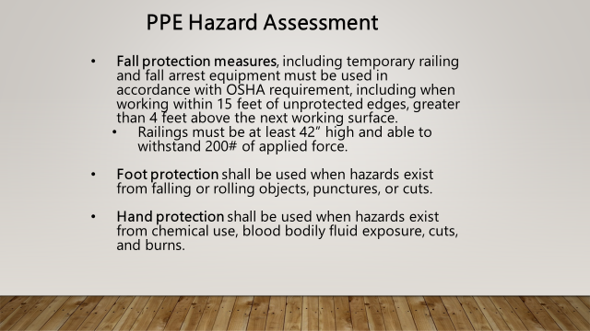

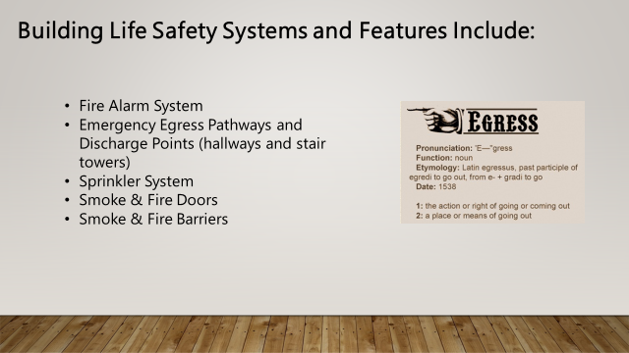

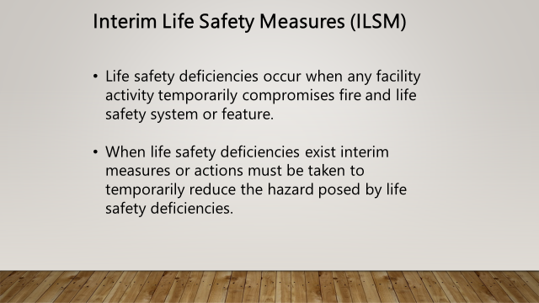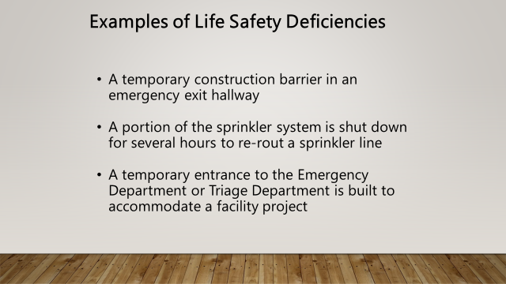

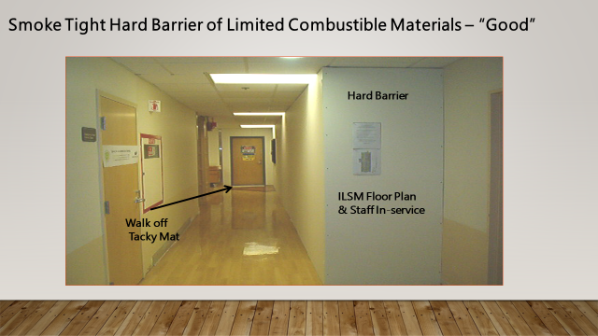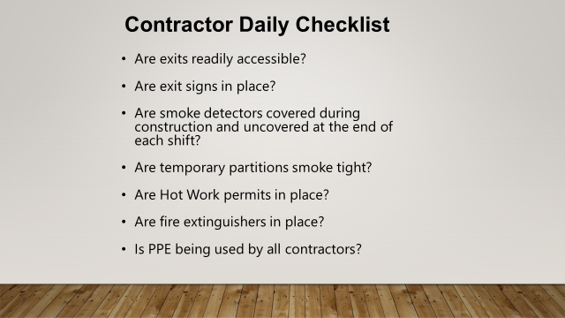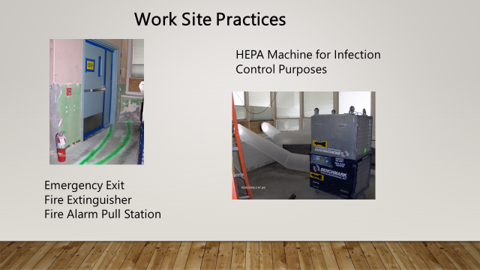

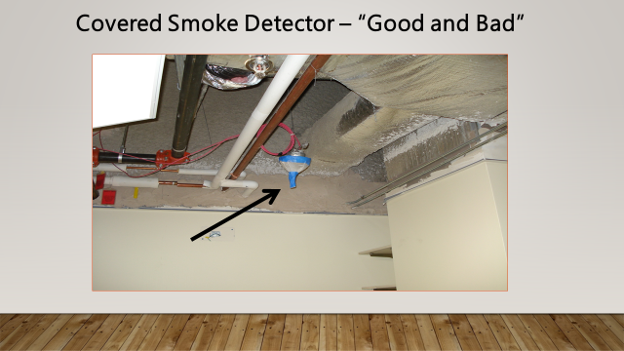

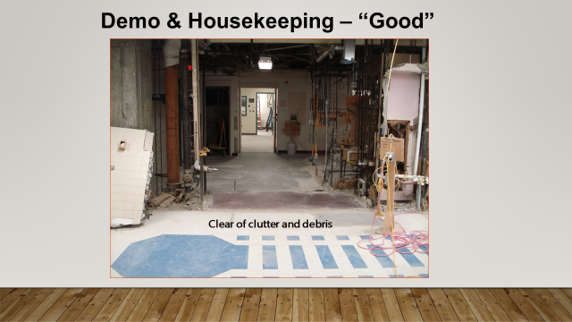

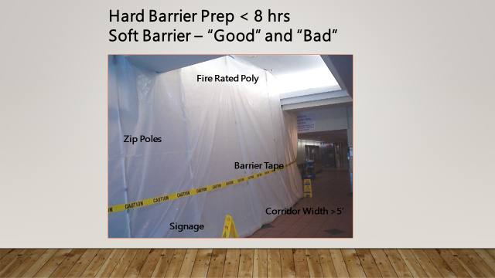

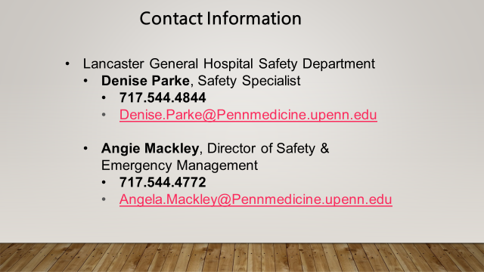

Lancaster General Health

Guideline for Construction Safety Management

**Policy:**

This guideline been developed to provide guidance on the minimum safe work practices in regard to fire safety, life safety, security practices, as well as environmental health and safety. This guideline must be reviewed by contractors upon initial assignment and at least annually thereafter.

**Scope:**

Allindividuals working under contract (referred to as “contractor” throughout this guideline) at any Lancaster General Health location.

**Purpose:**

The purpose of this guideline is to familiarize all contractors with the Lancaster General safety standards, put forth in order to maintain a safe and healthy work environment throughout all forms and phases of work. This guideline is to be used in conjunction with the contractors’ own established safety programs and standards.

**Definitions and Terms:**

1. Department of Health (DOH) –A regulatory body that enforces compliance with NFPA Life Safety Codes in health care facilities.
2. Health Insurance Portability and Accountability Act (HIPAA) - Privacy regulations which requires protection of Protected Health Information (PHI) and limits the disclosure of this information without the consent of the individual.
3. Infection Control Risk Assessment (ICRA) - Control measures to be taken to keep dust particles and exposure to dust to a minimum during all phases of construction projects, including those projects that involve work above the ceiling, for the protection of patients, staff, and visitors.
4. Interim Life Safety Measures (ILSM) - Actions put in place in order to compensate for life safety deficiencies, Contractors are responsible for conducting daily inspections of any areas under ILSM in the area(s) in which work is being done.
5. Lancaster General Emergency Conditions

* Condition Red –Fire
* Condition Yellow – Evacuation
* Condition Grey – High winds/Tornado
* Condition Black – Bomb Threat

1. Lancaster General Health facilities:

* Lancaster General Hospital
* Downtown Pavilion
* Women and Babies Hospital
* Suburban Pavilion
* Kissel Hill Outpatient Center
* Columbia Outpatient Center
* Crooked Oak Outpatient Center
* Eden Physical Therapy
* Willow Lakes Outpatient Center
* Norlanco Outpatient Center
* Ephrata Outpatient Center
* Parkesburg Outpatient Center
* Harrisburg Avenue Outpatient Center
* Walter L. Aument Family Health Center
* Norlanco Specialty Center
* Neuroscience Institute
* Ephrata Specialty Center
* County Line Outpatient Center
* Manheim Outpatient Center
* Lebanon Outpatient Center
* All other Lancaster General Hospital licensed satellite sites

1. Means of Egress - continuous and unobstructed way of exit travel from any point in a building to a public way.

1. National Fire Protection Agency (NFPA) – Organization focused on the development and publication of codes and standards that serve to minimize the possibility of fire and other hazards.
2. The Joint Commission (TJC)- Evaluates and accredits health care organizations and programs in the United States. This regulatory body enforces compliance with NFPA Life Safety Codes in health care facilities.

**Procedure:**

Contractors are responsible for the conduct of its personnel while on Lancaster General property. Failure to maintain proper conduct standards at all times may result in immediate removal of any contractor from LGH property, whether leased or owned.

**Injury and Illness Rates**

Contractors are responsible for providing Lancaster General with the company’s annual illness and injury rate information upon request. This information is required as part of Lancaster General’s participation in the OSHA Voluntary Protection Program (VPP).

**Security**

1. Before beginning work or a project, all contractors shall check in at thePlant Engineering Office (LGH), Facility Support Office (SP and WBH), or with a designated person, unless other arrangements are made. The outside contractor may be asked to supply the following information:

* identification
* scope of work
* authorization
* duration
* applicable and appropriate permits

1. If special parking is required, permission shall be granted and coordinated through LGH. Contractors should park at their own expense and/or atan approved location. Delivery schedules will be discussed and approved at pre-planning construction meetings.
2. Identification badges are required to be worn at all times while working in any LGH facility. It is the responsibility of the contractor to issue identification badges to all subcontractors and to enforce wearing the badges. Any contractor or subcontractor found not wearing an identification badge may be removed from the worksite.
3. Entry into a secured area will require advanced coordination prior to entry. Entry may be denied at any time for clinical or security reasons.

**Work Site Requirements**

1. It is the responsibility of the contractor’s safety management team to orient all contractors and subcontractors of Lancaster General Health’s policies and procedures outlined in this guideline.
2. All contractors are to maintain their work area as clean as possible while working and cleanup thoroughly when finished.
3. Emergency situations and near miss incidents must be reported to the owner’s representative and the Lancaster General Project Manager/designated person.
4. Any permits that are issued for the work that is being done need to be posted in a conspicuous location at the work site or they must be readily available for presentation upon request at the work site. Anyone working in an area without obtaining the appropriate permits (hot work permit, above ceiling work permit, confined space permit) and conspicuously posting them in the work area will be asked to immediately terminate work until such documentation can be presented.
5. All contractors working above the ceiling are required to replace all disturbed ceiling tile. Removal of ceilings and/or ceiling tiles should follow the ICRA protocols.
6. Prior to any utilities or critical systems being interrupted, advanced notification must be given to Plant Engineering, Facility Support, and Lancaster General Safety Departments.
7. All contractors are expected to use courtesy. Loud, vulgar, abusive language and aggressive behavior will not be tolerated.
8. Patient privacy is to be respected while working in or near patient care units or areas.
9. **Posting of Information:**
   1. “Lancaster General Hospital Emergency Information”
   2. “Lancaster General Hospital is a VPP Star Site”
   3. Permits for work as needed (i.e. Above Ceiling Work Permit, Hot Work Permit, ICRA)
10. **Elevator Use**: Holding public or patient elevators for use in any building in prohibited, unless these elevators have been designated for contractor use.
11. **Restroom Use**: Contractors are to use specific restrooms or portable facilities.
12. **Cafeteria Use**: This is prohibited.
13. **Dress Code**: No construction staff is allowed to remove shirts or other clothing unless working in a completely restricted area.
14. **Wireless Device Use**: Wireless devices may only be used in designated areas. Volume on two-way communication must be kept to a minimum, especially in patient care areas or where staff is working.
15. **Patient/Visitor Privacy:** No construction staff is allowed to review, acknowledge or move any patient information or records. Contact a clinician in order to move ANY patient records from the work area.
16. **Smoking:** This is a tobacco-free environment, No smoking on any LG Health facility or building leased by LG Health.
17. **Walking/Working Surfaces:** Per OSHA’s 29 CFR Part 1910, Subpart D&I, There is an expectation that walking/working areas will be free of tripping hazards such as extension cords and hoses on job sites. Use appropriate means to secure these items. If assistance is needed on how to eliminate these risks, reach out to the Safety Dept.

**Emergencies**

1. Accidents/Injuries - The contractor must post emergency phone numbers and treatment facilities for any injured employee (contractor packet document “Lancaster General Hospital Emergency Information”).
2. Any injury that occurs during an LGH project must be reported to the LGH Project Manager.
3. Emergency Numbers – Refer to the “Lancaster General Hospital Emergency Information Document” (to be posted in the worksite).
4. Emergency Conditions - Refer to the “Lancaster General Hospital Emergency Information Document” (to be posted in the worksite).

**Personal Protective Equipment (PPE)**

1. Each contractor should perform work in accordance with OSHA (e.g. 1926 Subpart E) and the site safety rules:
   1. Hard hats shall be worn at all times on site. Alterations or modifications of hat or liner are prohibited. Welders must wear a hard hat along with welding shields
   2. ANSI Z87 compliant safety glasses are required to be worn at all times. ANSI Z87 compliant face shields are also required in addition to safety glasses when grinding, chipping, cutting, etc.
   3. A face shield and safety glasses must be worn by contractors using hand held disc grinders, cut-off, and chop saws.
   4. Appropriate gloves are to be worn for the task being performed. Gloves with a cut rating of at least 3 are required to be worn at all times while work is being performed. (Unless a JHA has been prepared in advance indicating alternative hazard control).
   5. Hearing conservation is important. Contractors shall evaluate the level of noise emitted from their operations to ensure that, to the greatest extent possible, that the noise is attenuated. In the event that the noise levels cannot be mitigated, the Contractor shall provide workers with personal hearing protection
   6. Contractors must ensure that their workers have been medically cleared and properly trained to wear respirators. Respirators must be properly inspected, maintained, and used. The Contractor shall provide and utilize whatever engineering controls are necessary to limit exposure to harmful contaminants.
   7. Appropriate clothing that protects the body. No shorts, sweatpants, sneakers, sandals, sleeveless shirts, or clothing that is torn. The clothing shall be in good condition.
2. Contractors shall provide their workers with all required PPE that may be necessary to complete the assigned work.
3. The Contractor must ensure that each employee on-site has sturdy leather work boots with a rubber sole. Steel-toe work boots should be used as necessary for certain work activities/tasks.
4. Defective equipment must be immediately removed from service.

**Hazardous Materials**

1. Each contractor must establish and maintain an effective hazard communication program, compliant with OSHA 29 CFR 1910.1200.
2. All hazardous chemicals and products shall be handled, stored and used in accordance with applicable codes and standards.
3. Hazardous chemicals brought on site may be required to receive prior approval from the LGH Safety Department or Plant Engineering/ Facilities Management Departments.
4. All Material Safety Data Sheets must be maintained on site or there must be an effective system to obtain an MSDS within one shift of the request.
5. All containers containing hazardous substances shall be properly labeled to indicate contents, health hazards, fire hazards, and first aid measures.
6. Flammable liquids (defined as liquids having a flashpoint below 100˚ F) must be stored in a designated area. Quantities over one gallon must be stored in an approved safety can. Quantities of five gallons or greater must be stored in a safety cabinet.
7. Any chemical that is spilled must be immediately and properly cleaned up. Any material used in cleaning up a spill must be disposed of properly at the contracting company’s expense. Large spills or spills involving highly hazardous chemicals need to be reported immediately by calling the appropriate emergency phone number (refer to the “Lancaster General Hospital Emergency Information Document” (to be posted in the worksite).

**Hot Work Permits**

1. Hot work is to be performed in compliance with applicable codes and standards. A permit must be obtained prior to beginning any hot work.
2. All hot work permits are required to be posted at all times in a highly visible location where the hot work is being done. If a hot work permit cannot be produced upon request, the work may be terminated indefinitely or until a hot work permit is generated.
3. Hot work is any procedure that involves heat or open flame. It includes, but is not limited to the following:
   1. Cutting
   2. Grinding
   3. Brazing
   4. Welding
   5. Soldering

4. A fire watch will be required at all times during any hot work especially that which is performed in close proximity to combustible materials such as wood and paper products. A fire watch shall remain on duty for at least **30 minutes** after the completion of hot work.

5. Fire extinguishing equipment shall be provided in the immediate area of the hot work.

**Compressed Gas Cylinder Safety**

1. Handling, storage, and use shall comply with 29 CFR 1910.101, NFPA 50, Compressed Gas Association, and 1926.350.
2. All cylinders must be properly labeled identifying its contents.
3. All cylinders must be stored in an upright position and chained or fastened securely against a solid object (post, wall) to prevent accidental falling, tipping, or rolling. At no time should a cylinder be stored in a horizontal position on the floor or on top of storage racks.
4. When transporting cylinders they are to be firmly secured on appropriate carriers with the safety cap in place.
5. Cylinders (of specific typeM or H tank size)not in immediate use (with regulator attached) must be capped with a protective valve stem cap to protect the valve. All cylinder valves must be closed when not in use.
6. All compressed gas cylinders will be stored away from heat, flame, electrical equipment, and direct exposure to sunlight.
7. The storage of flammable and non-flammable gases will be segregated and the areas properly marked.
8. Full and empty gas cylinders must be segregated
9. Cylinders of flammable gasses will be stored at least 20 feet away from all sources of oxygen or nitrous oxide.
10. Combustibles must be stored at least 5 feet away from compressed gas cylinders in an area protected by an automatic sprinkler system and 20 feet in a space that is not protected by sprinklers.
11. Cylinders must be protected so as not to allow impact from a falling object.

**Lock Out/Tag Out**

1. All contractors are required to comply with the restrictions and limitations imposed upon them during the use of lockout/tag out.
2. No contract worker is allowed to change the status/position of ANY switch, valve or any other energy source without prior approval. Any activity requiring a Lockout/Tag out process must comply with the “LGH Lockout Tagout Tryout Policy”.
3. When performing lockout and/or tagout on any equipment, it must be completed in accordance with the OSHA standard 29 CFR 1910.147 “Control of Hazardous Energy Sources”.
4. Lockout and tag out devices must be durable and suitable for its application. At a minimum tags must be properly labeled with the name of the person applying the tag, the date it was placed and why. Each contracting company is responsible for supplying and properly using equipment necessary for all lockout and tagout procedures.

**Confined Space Entry**

1. Confined space entry and work within any confined space in accordance with OSHA (e.g. 1926 Subpart AA)
2. Contractors entering a confined space must have received training on confined space entry.
3. If entry into a permit required confined space is needed, Plant Engineering or Facility Support must be notified in advance. Any precautions or procedures that are specific for the permit confined space will be communicated at that time.
4. A permit will be required prior to entering and/or working in any confined space requiring a permit.
5. All equipment needed to monitor, enter, and work within the confined space will be provided by the contracting company. This includes ventilation equipment, rescue equipment, and communication devices.
6. Any employees from a contracting company who are entering a confined space will be responsible for reporting to Plant Engineering and Facility Support at the conclusion of the confined space activities.

**Asbestos**

1. Procedures outlined in the current version of 29 CFR1926.110, 29 CFR 1910.1001, as well as other requirements of the United States Environmental Protection Agency, Department of Environmental Protection, and all other federal and state regulations shall be adhered to throughout all asbestos projects.
2. Any work site involving asbestos abatement must be properly secured and labeled to restrict unauthorized access.
3. The licensed asbestos consultant shall perform project monitoring.  Monitoring shall include, but not be limited to daily inspection, air sampling inside and outside containment, and clearance air sampling as specified in the abatement contract.
4. Contractors are to be aware of the asbestos materials located in the vicinity of their work.
5. The contractor shall be responsible for maintaining the required continuous negative pressure environment within the work area throughout the entire abatement period. The contractor shall also be responsible for obtaining any legal certifications or licenses for any patented systems used on the project.
6. When a job has been completed, samples of the surrounding air are analyzed prior to the removal of the enclosure.  Based upon the results, the area is either cleared or re-cleaned and re-sampled.  If the area is declared "clear," it is opened to normal occupancy and all warning signs are removed.

**Infection Control Risk Assessment (ICRA)**

**Aspergillus** is an airborne fungal spore that lives on wood, paper, and the space above false ceilings. It is often found in construction dust and poses serious risks to patients who have weak immune systems or respiratory diseases.

Prior to all construction, renovation, and demolition activities, Refer to the Infection Control Construction Permit for additional prevention requirements.

1. A permit to work in occupied space and/or above the ceiling must be obtained prior to any work being performed in these areas.
2. Appropriate infection control measures must be taken to keep dust particles to a minimum during all phases of construction projects, including those projects that involve work above the ceiling.
3. Negative air pressure into the construction site must be maintained appropriately at all times
4. All ICRA barriers and dust control practices must remain in effect throughout the duration of any construction/renovation project that generates dust. Barriers must be properly assembled and fully inspected prior to any construction or demolition taking place.
5. This includes work requiring the removal of two or more ceiling tiles within a 50 square feet area.
6. All construction materials, including construction equipment and carts, must be covered or in sealed containers when transported through any patient care facility.
7. Tacky mats will be required at any point where the entrance into and/or the exit out of the construction site is made through the facility.

**Work in Emergency Exit Hallways and Stairwells**

1. Any work involving an emergency exit hallway or stairwell will require advanced notice to the LGH Safety Department.
2. Any blockage or re-routing of an emergency exit must be coordinated through the LG Safety Department and written approval must be received before alterations are made. All areas affected by the changes to any emergency egress pathway must receive notification, education, and training on alternate escape routes.
3. Signs or other means of notification must be utilized to warn people using the corridors or stairwells of work areas.

**Utilities Interruption**

1. Any work that will be performed on any utility system must be coordinated through LG Plant Engineering or Facility Support. A Utility Interruption Request form must be completed and submitted to Safety.
2. Planned outages:
   1. A minimum of 72 hours of advanced notice is required for minor utility outages.
   2. A minimum of 14 calendar days advance notice is required for major utility outages (**Major Utility Outage** = this is an outage that severely impacts a building, including the impact on patient care and employees ability to carry out procedures during an outage).

**Fire Protection & Prevention**

1. Any life safety code deficiencies incurred during construction or renovation, including emergency exit closure, will result in the implementation of Interim Life Safety Measures. All ILSMs must be approved and coordinated with the LGH Safety Department and LGH Project Management prior to ILSM implementation.
2. Any penetrations that are made as a result of any work must be repaired upon completion of the project.
3. Temporary construction partitions of non-combustible or limited combustible materials shall be installed to separate the construction area from the rest of the facility, especially with any portion of the fire alarm system taken out of service.
4. All necessary precautions shall be taken by the contractor to prevent accidental operation the fire alarm system by minimizing the amount of dust generated in the vicinity of any smoke detectors. When conducting any smoke or dust-producing work, impairment of portions of the fire alarm system should be considered and must be coordinated in advance with the LGH Safety Department, Plant Engineering and Facility Support.
5. An hourly fire watch must be conducted whenever any portion of the fire alarm system is out of service for more than 4 hours and sprinkler system is out of service for more than 8 hours.
6. At the end of each workday, combustible storage and trash shall be removed from the worksite.
7. Emergency egress pathways must remain clear so that all portions are accessible for fire department apparatus and permit emergency egress of patients, visitors, and personnel.
8. Doors are not permitted to be blocked open.
9. The necessary number and appropriate type of portable fire extinguishers per applicable codes and standards shall be provided for all construction areas by the contracting company performing the work.
10. All fire extinguishers shall be tagged and properly inspected per NFPA 10.
11. All temporary electrical wiring and equipment used for construction shall be installed and used in accordance with pertinent codes and standards.
12. Daily work site inspections shall be conducted, focusing on the following areas: fire hazards, housekeeping, inspections shall be conducted daily by the contractor once construction starts and until the work is turned back over to the facility.
13. Combustible materials (oil-soaked rags, paper, etc) shall be stored in a metal container with self-closing metal lid.
14. Fire extinguishers and fire alarm pull stations must remain unobstructed at all times.
15. Any temporary systems (heat detectors, pull stations) that are put in place during construction are required per TJC to be inspected and tested monthly. Contractors are to make arrangements with Plant Engineering on a time to run the tests. Plant Engineering will maintain paperwork.

**Crane Use**

1. Any time a crane is needed on a job site and near a helipad or airport, the FAA is to be notified by LGH’s Emergency Communications Center.
2. The following information is required and needs to be reviewed by Safety, Plant Engineering, and/or Facilities.
   * 1. Google Earth shot overview plan detailing crane/material delivery truck positioning-include GPS coordinates
     2. Boom rotation
     3. Crane specifications- size, weight, boom length
     4. Crane maintenance log
     5. Crane operator certifications
     6. Rigging personnel certifications
     7. Boom end must have caution flag installed at all times while extended.

**Lancaster General Health Safety Specifications and Life Safety Requirements**

**Summary**

This section specifies safety requirements during all phases of facility work and projects, including alterations and renovations.

**Procedure**

1. Fire and Life Safety
   1. Prior to commencing construction activities, life safety measures must be reviewed by the Lancaster General Hospital Safety Department.
   2. Any life safety code deficiencies incurred during construction or renovation will result in following the Lancaster General’s Interim Life Safety Measures Policy. The Joint Commission and Department of Health require these measures. The contractor will be responsible for maintaining any required documentation. Items requiring an ILSM implementation (not limited to this list) include activities that impact or change exits, stairs, and/or fire/smoke walls; impairments of the sprinkler or fire alarm systems; dead end corridors
   3. Existing Fire Protection:
      1. Existing fire protection systems, including fire alarm systems, smoke detection systems, and sprinkler systems, shall not be impaired except as required for the alteration and/or renovation project. If these systems are impaired, the following is required:
         1. Provide documentation of hourly fire watch for fire alarm impairments lasting 4 or more hours in a 24-hour period and/or sprinkler system impairments lasting 8 or more hours in a 24-hour period.
         2. Impairments shall be coordinated with Lancaster General Hospital.
      2. Remove all temporary covers from smoke detectors and sprinklers at the end of work operations each day.
      3. Reactivation of fire and/or sprinkler systems at the end of work operations each day.
      4. Install, test and activate new automatic sprinklers and/or fire detection devices prior to removing existing sprinklers and/or fire detection devices.
   4. Sprinklers:
      1. Sprinklers, sprinkler lines, and medical lines must be free from materials and objects at all times.
      2. Sprinklers will be maintained and turned up in a construction area if there are no rated walls provided to divide construction space from other working spaces.
   5. Means of Egress:
      1. Corridor width must be maintained at least 6 feet.
      2. All exit components for occupied areas of the building including rooms, suites, corridors and floors shall not be blocked or altered by construction activities, construction materials, or temporary barriers. Egress routes from the construction site must be maintained free of obstructions.
      3. If exit components must be altered temporarily, alternative measures must be reviewed and approved by the Lancaster General Hospital Safety Department.
      4. Maintain exit lighting in work area.
   6. Fire Extinguishers: Provide and maintain the required number and type of fire extinguishers in construction areas and temporary storage areas.
   7. Temporary Construction Partitions:
      1. Install and maintain temporary construction partitions to provide smoke-tight separations between the construction areas and adjoining occupied areas.
      2. Construct barriers of limited combustible materials to provide a minimum 1-hour smoke separation. Construction barriers must maintain the same resistance rating of existing exit stair enclosures, exit passageways, fire-rated enclosures of hazardous areas, horizontal exits, smoke barriers, vertical shafts and openings enclosures.
      3. Any doors used in temporary barriers must be constructed of limited combustible materials.
      4. Temporary construction barriers must be maintained to prevent dust migration to prevent accidental activation of the fire alarm system.
      5. All penetrations must be sealed with approved fire stop materials.
      6. At door openings, install Class C, ¾ hour fire/smoke rated doors with self-closing devices.
   8. Site and Building Access: Maintain free and unobstructed access to facility emergency services and for fire, police and other emergency response forces.
2. Interior Finishes:
   1. Interior finishes and contents must be classified as Class A, so that it does not contribute to the spread of fire.
   2. Plywood must be fire-retardant treated. Evidence that it’s fire-retardant must be documented prior to painting the surface (i.e. photograph showing location and label).
3. Emergency Plan:
   1. Prepare a plan detailing project-specific emergency measures and procedures. Orient contractors to this plan and post the information in the construction site.
   2. Prior to any contractor or subcontractor begins work, they shall undergo a safety briefing provided by the general contractor’s competent person per OSHA requirements. This briefing shall include information on the Lancaster General Hospital’s safety guidelines, means of egress, and work site safety requirements. Documentation shall be maintained by the general contractor that individuals have undergone contractor’s safety briefing.
   3. Accidents/Injuries:
      1. The contractor must post emergency phone numbers and treatment facilities for any injured employee.
      2. Any injured contractor is to follow the contractor’s company procedure for reporting an injury.
      3. Lancaster General Hospital is to be notified of any accident or injury that occurred in any Lancaster General facility.
4. Hot Work: Hot Work Permits shall be assigned prior to any cutting or welding being conducted. A fire watch must remain for at least 30 minutes following completion of work and must be documented.
5. Documentation:
   1. Document inspection of the construction site and its surrounding areas daily; reporting findings and corrective actions to the LGH Safety Department.
   2. Copies of inspections performed by the contractor are to be sent to the Lancaster General Hospital Safety Department (fire watch, daily inspections).
6. Smoking: Smoking is prohibited at all Lancaster General Hospital facilities.
7. Hazardous Materials
   1. Material Safety Data Sheets must be available for chemicals used onsite
   2. All flammable liquids must be properly handled and stored.

**References**

1. Lancaster General Hospital Policies
   1. Electrical Safety Program
   2. Hazardous Substance and Spill Procedures and Practices
   3. Compressed Gas Safety
   4. Corridor and Stairwell Safety
   5. Storage and Use of Flammables
   6. Tobacco Free Environment Policy
   7. Interim Life Safety Measures (ILSM)
   8. LGH Guideline for Construction Safety Management
2. Additional References:
   1. National Fire Protection Association (NFPA):
      1. NFPA 10 Standard for Portable Fire Extinguishers
      2. NFPA 13 Standard for the Installation of Sprinkler Systems
      3. NFPA 25 Standard for the Inspection, Testing, and Maintenance of Water-Based Fire Protection Systems
      4. NFPA 30 Flammable and Combustible Liquids Code
      5. NFPA 80 Standard for Fire Doors and Other Opening Protectives
      6. NFPA 99 Health Care
      7. NFPA 101 Life Safety Code
      8. NFPA 241 Standard for Safeguarding Construction, Alteration, and Demolition Operations
   2. Occupational Safety and Health Administration (OSHA):
      1. 29 CFR 1926 and 29 CFR 1910

**Lancaster General Health**

**EMERGENCY INFORMATION**

|  |  |
| --- | --- |
| *Non-Medical Emergency*  *(chemical spill, fire)*  ***73911*** | *Medical Emergency*  ***911*** |

*LGH Project Managers*

Mark Matuzak Scott Widdall Stacie Doman Nicole Derk

717-544-1742 717-544-2398 717-544-2653 717-544-2654 717-585-7602

*LGH Plant Engineering WBH/SP Facility Support*

*717-544-7192 717-544-3888*

*LGH Safety Department*

Angela Mackley Denise Parke

717-544-4772 717-544-4844

*LGH Infection Control*

Rebecca Ponniah Deb Hess

717-544-4183 717-544-5560

CONDITION RED FIRE

Rescue anyone in the immediate area

Alarm by activating the nearest pull station

Contain the fire by closing doors in the area. Clear hallways.

Extinguish if it can be done safely OR Evacuate the area immediately

When the fire alarm activates:

Stop all activities

DO NOT move through building, except if in the process of evacuation

DO NOT use elevators

***CONDITION YELLOW EVACUATION***

**The designated meeting point upon evacuating is:**

*INSERT EVACUATION INFORMATION HERE*

**CONDITION GREY TORNADO**

Verify all loose material and debris outside is appropriately tied down and secured. Stay within the construction limits, away from windows and wait for further instruction.

**CONDITION BLACK BOMB THREAT**

If directed to evacuate, proceed to the area where directed to or proceed to the designated meeting point (listed above).





Lancaster General Hospital was awarded Star Status through OSHA’s Voluntary Protection Program (VPP) in 2007.

**All About OSHA VPP**

**What is VPP?**

The Voluntary Protection Programs (VPP) promote effective worksite-based safety and health. In the VPP, management, labor, and OSHA establish cooperative relationships at workplaces that have implemented a comprehensive safety and health management system. Approval into VPP is OSHA’s official recognition of the outstanding efforts of employers and employees who have achieved exemplary occupational safety and health.

**What Is the Authority for VPP?**

The legislative underpinning for VPP is Section (2)(b)(1) of the Occupational Safety and Health Act of 1970, which declares the Congress’s intent "to assure so far as possible every working man and woman in the Nation safe and healthful working conditions and to preserve our human resources - (1) by encouraging employers and employees in their efforts to reduce the number of occupational safety and health hazards at their places of employment, and to stimulate employers and employees to institute new and to perfect existing programs for providing safe and healthful working conditions."

**How Does VPP Work?**

In practice, VPP sets performance-based criteria for a managed safety and health system, invites sites to apply, and then assesses applicants against these criteria. OSHA’s verification includes an application review and a rigorous onsite evaluation by a team of OSHA safety and health experts. OSHA approves qualified sites to one of three programs:

* Star
* Merit

Star Demonstration: Recognition for worksites that address unique safety and health issues. Sites that make the grade must submit annual self-evaluations and undergo periodic onsite reevaluations to remain in the programs.

**When Did VPP Begin?**

1979 - California began experimental program

1982 - OSHA formally announced the VPP and approved the first site.

1998 - Federal worksites became eligible for VPP.

**How Has VPP Improved Worker Safety & Health?**

Statistical evidence for VPP’s success is impressive. The average VPP worksite has a Days Away Restricted or Transferred (DART) case rate of 52% below the average for its industry([1](http://www.osha.gov/dcsp/vpp/all_about_vpp.html#footnote)). These sites typically do not start out with such low rates. Reductions in injuries and illnesses begin when the site commits to the VPP approach to safety and health management and the challenging VPP application process.

**How Does VPP Benefit Employers?**

Fewer injuries and illnesses mean greater profits as workers’ compensation premiums and other costs plummet. Entire industries benefit as VPP sites evolve into models of excellence and influence practices industry-wide.

**How Does VPP Benefit OSHA?**

OSHA gains a corps of ambassadors enthusiastically spreading the message of safety and health system management. These partners also provide OSHA with valuable input and augment its limited resources.

Another benefit to OSHA is a safety and health advocacy group that came into existence as a result of the VPP, the Voluntary Protection Program Participants’ Association (VPPPA). The VPPPA is a nonprofit organization founded in 1985. As part of its efforts to share the benefits of cooperative programs, the VPPPA works closely with OSHA and State Plan States in the development and implementation of cooperative programs. The VPPPA also provides expertise to these groups in the form of comments and stakeholder feedback on agency rulemaking and policies. Additionally, the Association provides comments and testimony to members of Congress regarding legislative bills on health and safety issues.

 

*Lancaster General Health Request for Injury and Illness Rate Information*

*COMPANY NAME:*

*NAICS NUMBER:*

|  |  |  |  |  |  |  |  |  |  |
| --- | --- | --- | --- | --- | --- | --- | --- | --- | --- |
| **2014 Recordable Injury and Illness Case Incidence Rates** | | | | | | | | | |
| **1** | **2** | **3** | **4** | **5** | **6** | **7** | **8** | **9** | **10** |
| **Year** | **Total Work Hours** | **Total # of Injuries** | **Total # of Illnesses** | **Total # of Injuries & Illnesses** | **Total Case incidence Rate for Injuries and Illnesses (TCIR)** | **Total # of Injuries Involving Days Away from Work, Restricted Work Activity, and/or Job Transfer** | **Total # of Illnesses Involving Days Away from Work, Restricted Work Activity, and/or Job Transfer** | **Sum of Injury & Illness Cases Involving Days Away from Work, Restricted Work Activity, and/or/ Job Transfer** | **Days Away, Restricted, and/or Transfer Case Incidence Rate (DART rate)** |
| **2014** |  |  |  |  |  |  |  |  |  |
| **Most recent published BLS rate (2013)** | | | | |  |  |  |  |  |
| **% above or below National Average** | | | | |  |  |  |  |  |

Additional Information:

1. Approximate number of employees who worked at an LGH facility last calendar year? _____
2. Number of recordable injuries that occurred while working at an LGH facility last calendar year? _____

Directions for completing the table above:

* Column 2: Insert the total person hours worked for the year (not an estimate).
* Column 3: Insert the total number of OSHA recordable injuries for the year.
* Column 4: Insert the total number of OSHA recordable illnesses for the year.
* Column 5: Insert the sum of columns 3and 4.
* Column 6: Insert TCIR = (total recordable injuries and illnesses ÷ total hours worked) x 200,000
* Column 7: Insert the total number of OSHA recordable injuries involving days away from work, restricted work activity, and/or job transfer.
* Column 8: Insert the total number of OSHA recordable illnesses involving days away from work, restricted work activity, and/or job transfer
* Column 9: Insert the sum of columns 7 and 8.
* Column 10: Insert DART = (total recordable injuries and illnesses resulting in days away, restricted work activity, and/or job transfer ÷ total hours worked) x 200,000
* BLS data: Insert the TCIR and DART rate for your industry from BLS's Table of Incidence Rates of Nonfatal Occupational Injuries and Illnesses by Industry. Find the table at [www.BLS.gov](http://www.osha.gov/pls/oshaweb/owaredirect.html?p_url=http://www.bls.gov) or obtain from your Regional VPP Manager.  
  Compare your rates to BLS:  Calculate the percent above or below the BLS national average for your TCIR and DART rate using the formula: [(Site rate - BLS rate) ÷ BLS rate] x 100

**RETURN THIS FORM TO THE VPP REPRESENTATIVE; BobbiJo.Hurst@pennmedicine.upenn.edu**